Dear Applicant

Thank you for the interest you have shown in the role of **Executive Office Manager**.

I am the MP for Rotherham and Chair of the International Development Select Committee. I am also a member of other committees and APPGs. Please be aware that all of this may change after the general election.

I am looking for someone with at least two years’ previous experience in a similar role; that could be as an Executive PA, running an office or project management.

Principally, I need you to ensure the smooth running of the office, the team – who are split between Rotherham and London and provide me with the support I need to operate in a frenetic environment.

You will manage the finances, the team HR and keep the office stocked. I will need you to co-ordinate and provide support on various campaigns that emerge from constituency. This is likely to mean that you will be engaging with stakeholders, talking to constituents, managing the communication and attending meetings in a representative capacity. You need to have excellent organisation and communication skills.

Accuracy and attention to detail is key to this role, and you need to demonstrate that it is also key to your working practice.

You will be constantly horizon scanning, monitoring the media engaging with stakeholders to keep me informed on topical news relevant to the constituency and my work in Parliament. The role also involves supporting the rest of my team with their work where necessary and providing line management to the very small administrative team. You should have strong interpersonal skills and be confident meeting visitors and attending meetings on my behalf where needed.

Parliament dictates this role and so you need to be flexible in relation to hours, workload and topics. I need someone who is always thinking ahead, always has a plan B and is not phased by a rapidly changing environment. I will need you to hold a full UK driving licence.

The deadline for applications is **5pm Monday 1st April**. Please note that any applications received after this will be discounted. Please use the application form provided, anything in addition to this form will not be read, that includes CVs.

I am anticipating a lot of interest in the post so I apologise in advance that I will only be contacting those selected for interview by **5pm on Friday 5th April**. I know it takes a lot of time to complete an application form, so I am sorry that I cannot contact everyone with a personal reply and feedback, but I only have a small team and we do not have capacity. Interviews will be in person during the day on **18th April**

I am very grateful you are considering applying as I know how much time it takes.

Kindest regards

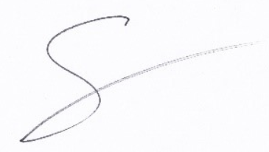

Sarah

nature_430843729

**Sarah Champion**

**Labour Member of Parliament for Rotherham**

**Chair of the International Development Select Committee**